Project Design Phase-II
Technology Stack (Architecture & Stack)

Date | 20 February 2026
Team ID | LTVIP2026TMIDS80887
Project Name | FreelanceFinder: Discovering Opportunities, Unlocking Potential
Maximum Marks | 4 Marks

Technical Architecture:
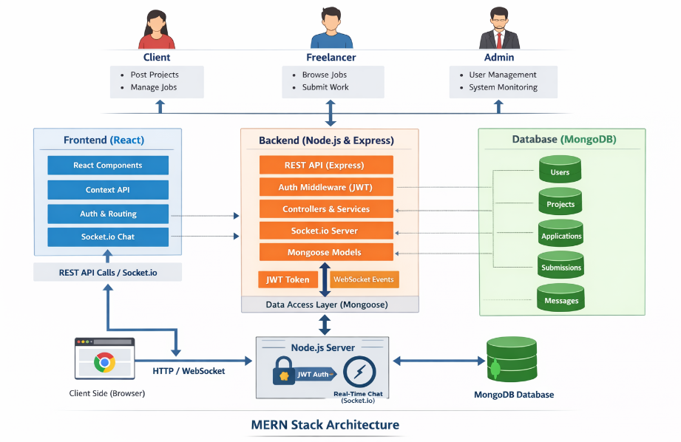

Table-1: Components & Technologies:

S. No | Component | Description | Technology
 | User Interface | Web interface for clients and freelancers to register, browse projects, apply, chat, and manage work | HTML, CSS, JavaScript, React.js, Bootstrap
 | Application Logic-1 | User authentication, registration, role management, profile handling | Node.js, Express.js
 | Application Logic-2 | Project management, bidding system, freelancer selection | Express.js, Node.js
 | Application Logic-3 | Real-time chat and notifications between client and freelancer | Socket.IO
 | Database | Stores users, freelancers, projects, applications, chats, reviews | MongoDB, Mongoose
 | Cloud Database | Database hosting in cloud | MongoDB Atlas
 | File Storage | Storage for portfolio files, project attachments, submission files | Cloudinary / Local Storage
 | External API-1 |  | Nodemailer/ SMTP
  Email notifications for registration, project updates, and messages
 | External API-2 | Authentication and secure password handling | JWT/ bcrypt
 | Infrastructure (Server / Cloud) | Backend server deployment and hosting of full-stack MERN application | Node.js Server, Render / AWS / Vercel

Table-2: Application Characteristics:

S. No | Characteristics | Description | Technology
 | Open-Source Frameworks | Frameworks used to develop frontend and backend | React.js, Node.js, Express.js, Bootstrap
 | Security Implementations | Secure authentication, password encryption, protected APIs | JWT Authentication, bcrypt hashing, HTTPS
 | Scalable Architecture | MERN 3-tier architecture separating UI, server, and database | React + Node/Express + MongoDB
 | Availability |  | Render / Vercel / MongoDB Atlas
  Cloud hosting ensures 24/7 platform access
 | Performance | Efficient API communication and optimized frontend rendering | Axios, REST APIs, React Virtual DOM

